2.1 Introduction
No new significant environmental impacts or issues, beyond those already covered in the Draft Environmental Impact Report (Draft EIR) for the 2013 Cotati General Plan Update, were raised during the comment period. Responses to comments received during the comment period do not involve any new significant impacts or “significant new information” that would require recirculation of the Draft EIR pursuant to CEQA Guidelines Section 15088.5.
CEQA Guidelines Section 15088.5 states that: New information added to an EIR is not “significant” unless the EIR is changed in a way that deprives the public of a meaningful opportunity to comment upon a substantial adverse environmental effect of the project or a feasible way to mitigate or avoid such an effect (including a feasible project alternative) that the project’s proponents have declined to implement.
Chapters 2.0 and 3.0 of this Final EIR include information that has been added to the EIR since the close of the public review period in the form of responses to comments and errata.

2.2 List of Commenters
Table 2-1 lists the comments on the Draft EIR that were submitted to the City during the 45-day public review period. The assigned comment letter number, letter date, letter author, and affiliation, if presented in the comment letter or if representing a public agency, are also listed.

Table 2-1: List of Commenters
Response  Letter | Individual or Signatory | Affiliation | Date
A | Erik Alm, AICP | Caltrans | 10/24/14
B | Beth Dadko | Sonoma County | 10/24/14
C | Jenny Blaker | Resident | 10/24/14
D | Bryant R. Moynihan | Nexus Realty Group | 9/9/14
E | Robin Miller | Cotati Vintners Collective | 10/23/14
F | Robin Miller | Highway 116 Associated Investors | 10/23/14
G | Robin Miller | Townsend Capital Partners | 10/23/14
H | Linell Hardy | Resident | 10/24/14

2.3 Comments and Responses

Requirements for Responding to Comments on a Draft EIR
CEQA Guidelines Section 15088 requires that lead agencies evaluate and respond to all comments on the Draft EIR that regard an environmental issue. The written response must address the significant environmental issue raised and be detailed, especially when specific comments or suggestions (e.g., additional mitigation measures) are not accepted. In addition, the written response must be a good faith and reasoned analysis. However, lead agencies only need to respond to significant environmental issues associated with the project and do not need to provide all of the information requested by the commenter, as long as a good faith effort at full disclosure is made in the EIR (CEQA Guidelines Section 15204(a)).
CEQA Guidelines Section 15204 recommends that commenters provide detailed comments that focus on the sufficiency of the Draft EIR in identifying and analyzing the possible environmental impacts of the project and ways to avoid or mitigate the significant effects of the project, and that commenters provide evidence supporting their comments. Pursuant to CEQA Guidelines Section 15064, an effect shall not be considered significant in the absence of substantial evidence.
CEQA Guidelines Section 15088 also recommends that revisions to the Draft EIR be noted as a revision in the Draft EIR or as a separate section of the Final EIR. Chapter 3.0 of this Final EIR identifies all revisions to the 2013 Cotati General Plan Update Draft EIR.

Responses to Comment Letters
Written comments on the Draft EIR are reproduced on the following pages, along with responses to those comments. To assist in referencing comments and responses, the following coding system is used:
- Each comment letter is lettered (i.e., Letter A), each comment within each letter is numbered (i.e., Comment A-1, Comment A-2, etc.), and each response is numbered correspondingly (i.e., Response A-1, Response A-2, etc.).
Where changes to the Draft EIR text result from the response to comments, those changes are included in the response and identified with revisions marks (underline for new text, strike out for deleted text).
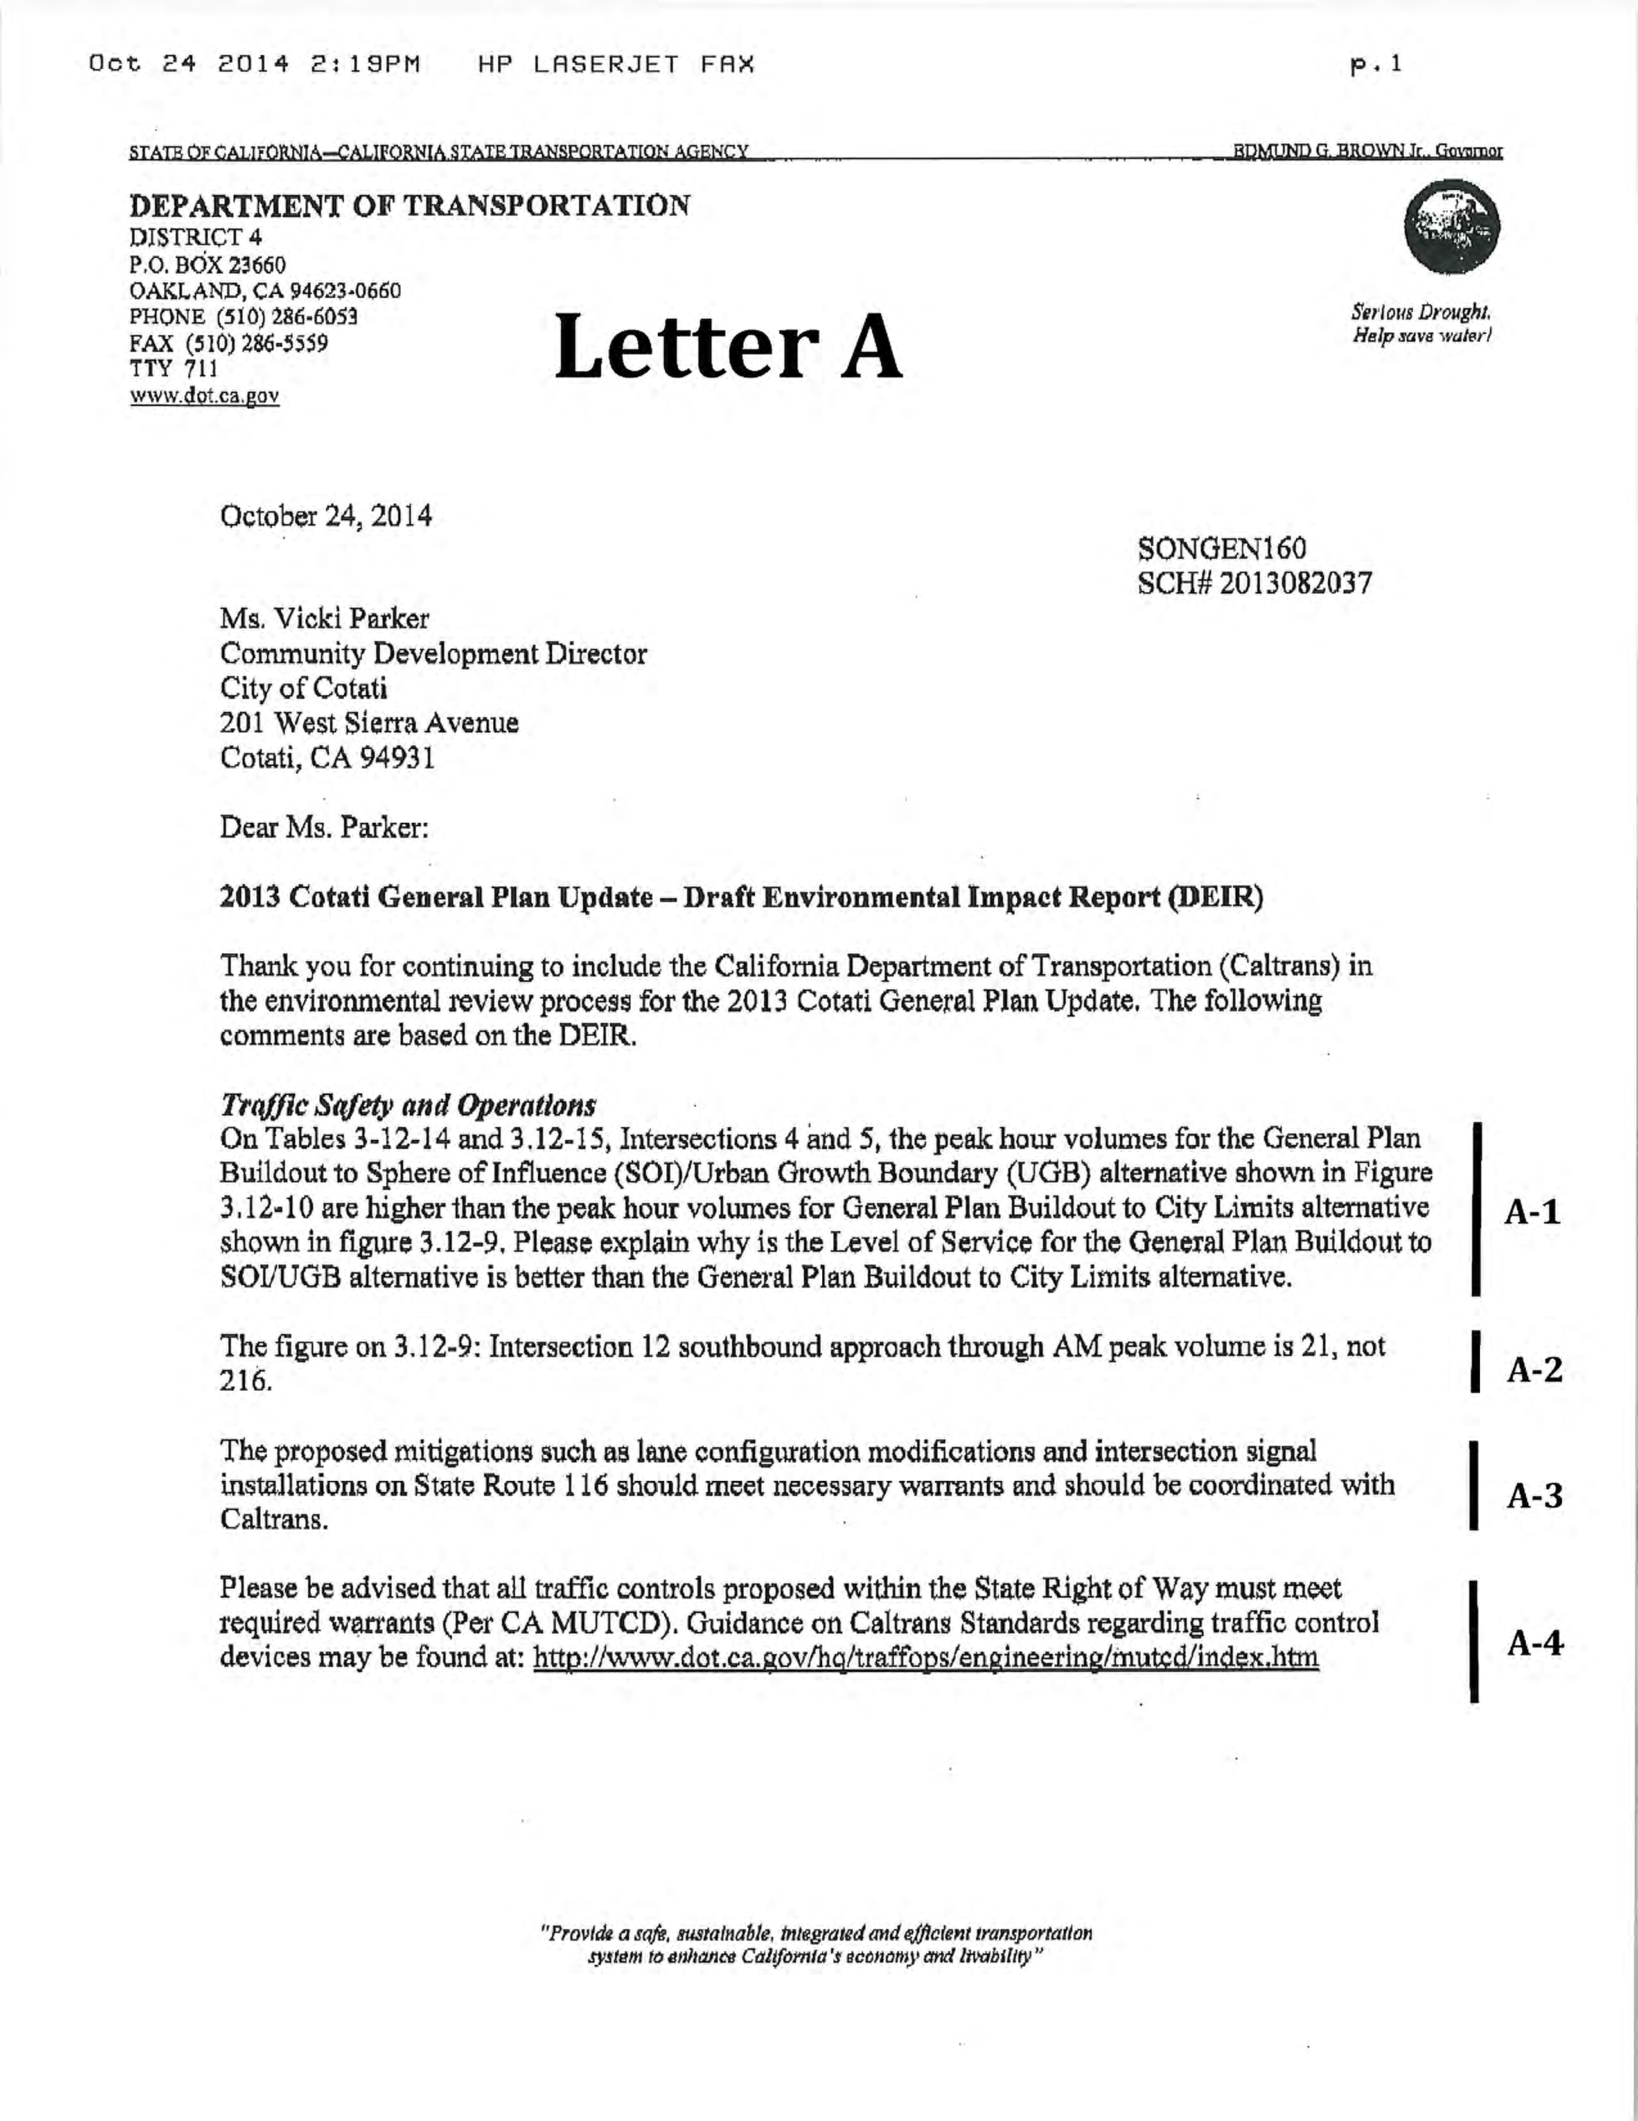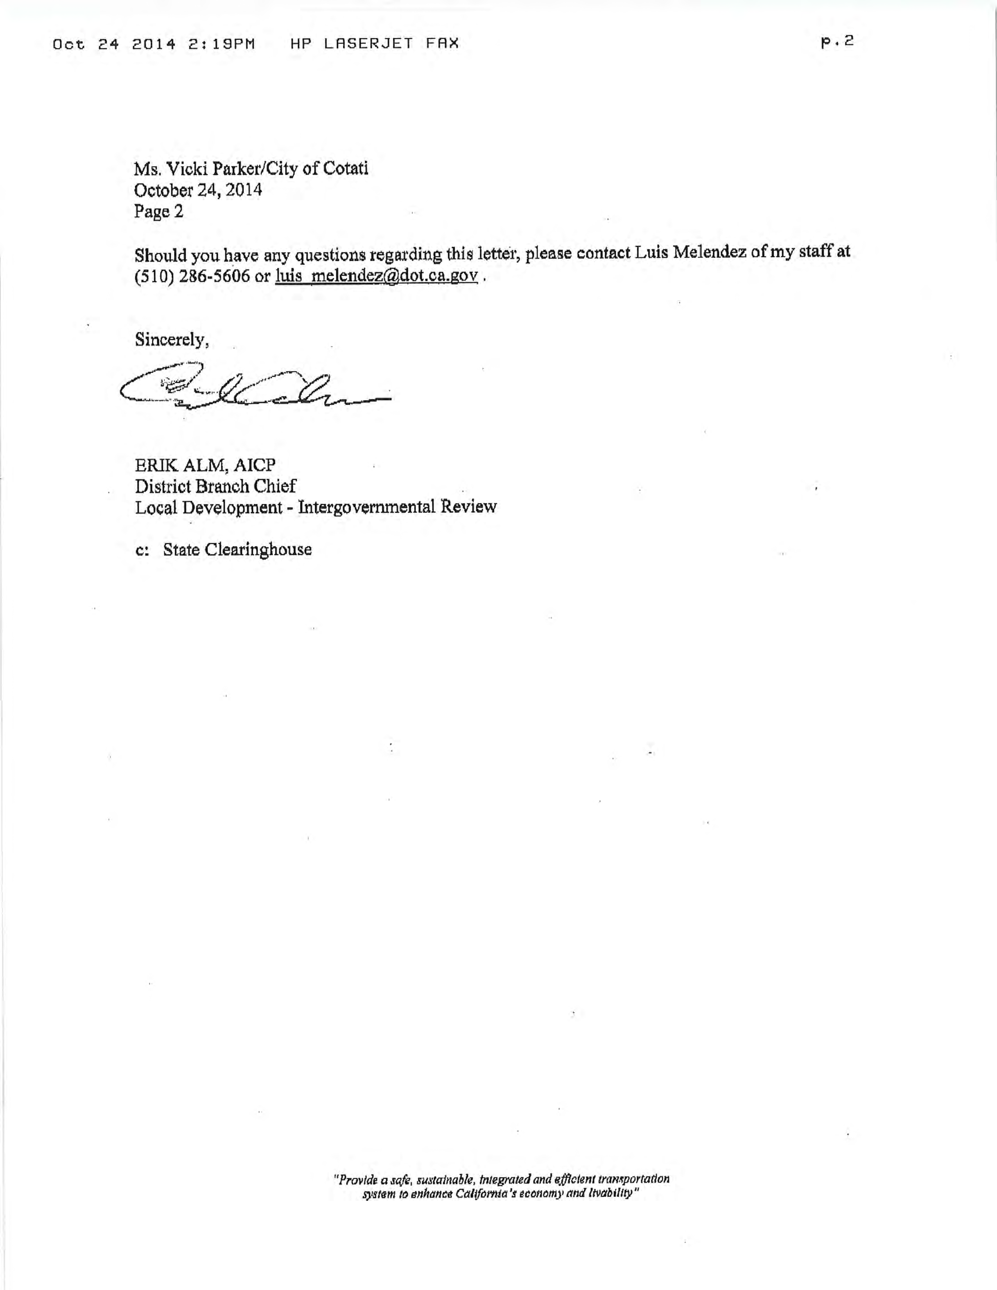

Response to Letter A Erik Alm, AICP, Caltrans

Response A-1: The commenter correctly notes that traffic volumes at intersections 4 and 5 are higher under the General Plan Buildout to SOI/UGB alternative than they are for the General Plan Buildout to City Limits alternative, and asks why the intersection levels of service are not correspondingly worse. The reason is that the General Plan includes additional roadway improvements under the Buildout to SOI/UGB alternative beyond those assumed in the City Limits alternative. These additional improvements are identified on pages 3.12-21 through 3.12-23 of the DEIR and include a second right-turn pocket on the southbound off-ramp, as well as improvements at upstream and downstream intersections that allow the Gravenstein Highway corridor and interchange-area intersections to operate more efficiently (and at better LOS).
Response A-2: The commenter notes a typo regarding traffic volumes on Intersection 12 on Figure 3.12-9. The commenter is correct. The figure incorrectly showed 216 southbound AM approach trips, rather than correctly showing 21 trips. This typo has been corrected. The revised and corrected figure is included in Section 3.0 of this Final EIR. The analysis in the Draft EIR used the correct trip numbers. The error was simply a typo on the figure. As such, the analysis and conclusions in the Draft EIR were not affected by this minor figure error.
Response A-3: The commenter states that proposed roadway and signal improvements on State Route 116 should meet necessary warrants and should be coordinated with Caltrans. This comment is noted. The City will coordinate with Caltrans, as applicable and appropriate, on future roadway improvements on State facilities.
Response A-4: The commenter states that traffic controls within the State Right of Way must meet required warrants and provides a web link to guidance documents on Caltrans standards. This comment is noted. The City will coordinate with Caltrans, as applicable and appropriate, on future roadway improvements within the State Right of Way.

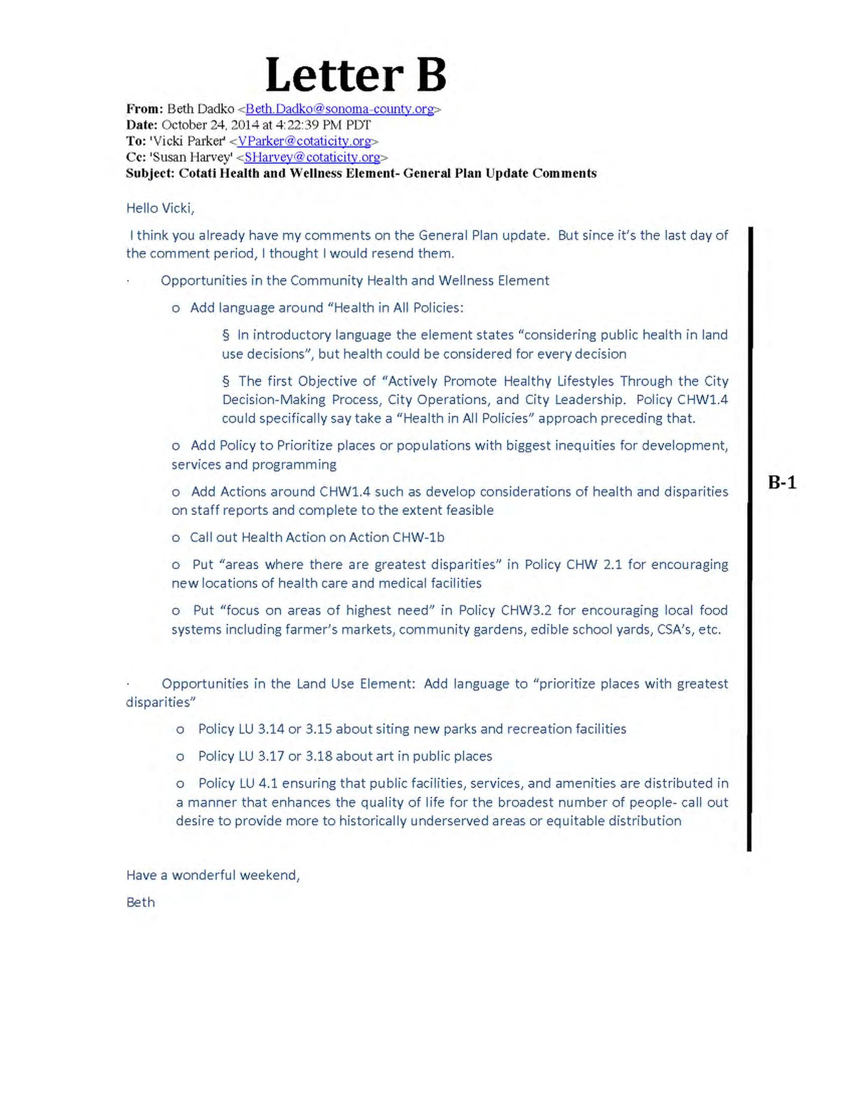
Response to Letter B Beth Dadko, Sonoma County

Response B-1: The commenter provides a range of suggested language related to community health and wellness policies in the Draft General Plan. The City appreciates this input, and these comments and suggestions have been forwarded to the City Council for their review and consideration. Given that these comments do not address the adequacy of the Draft EIR and would have no bearing on the environmental analysis, no changes to the EIR are warranted.
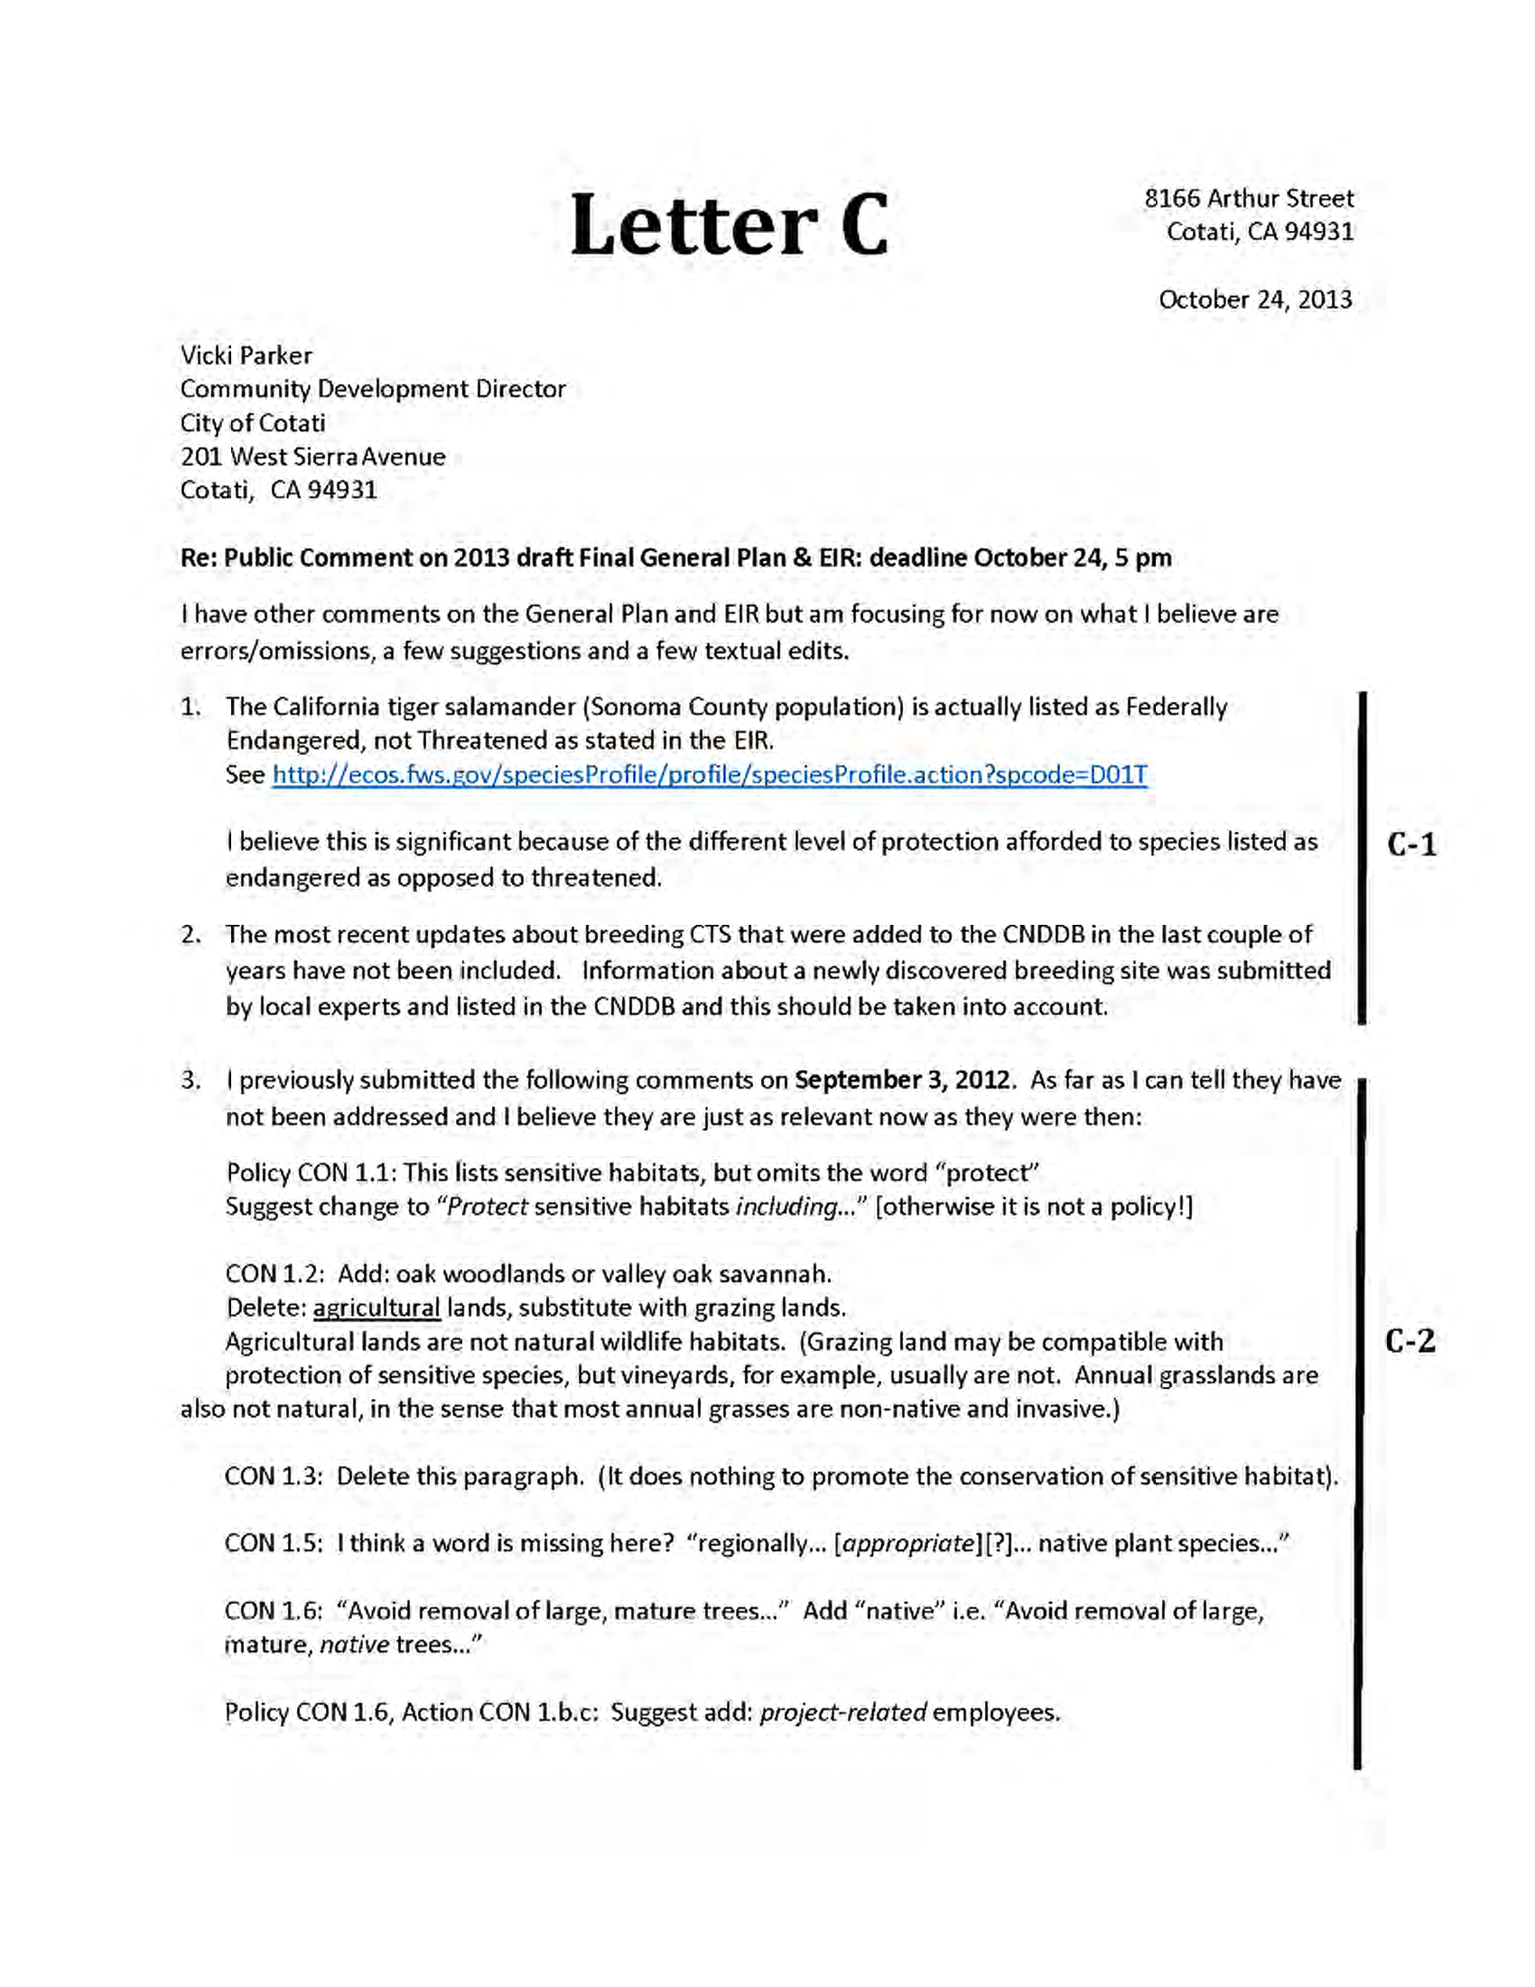
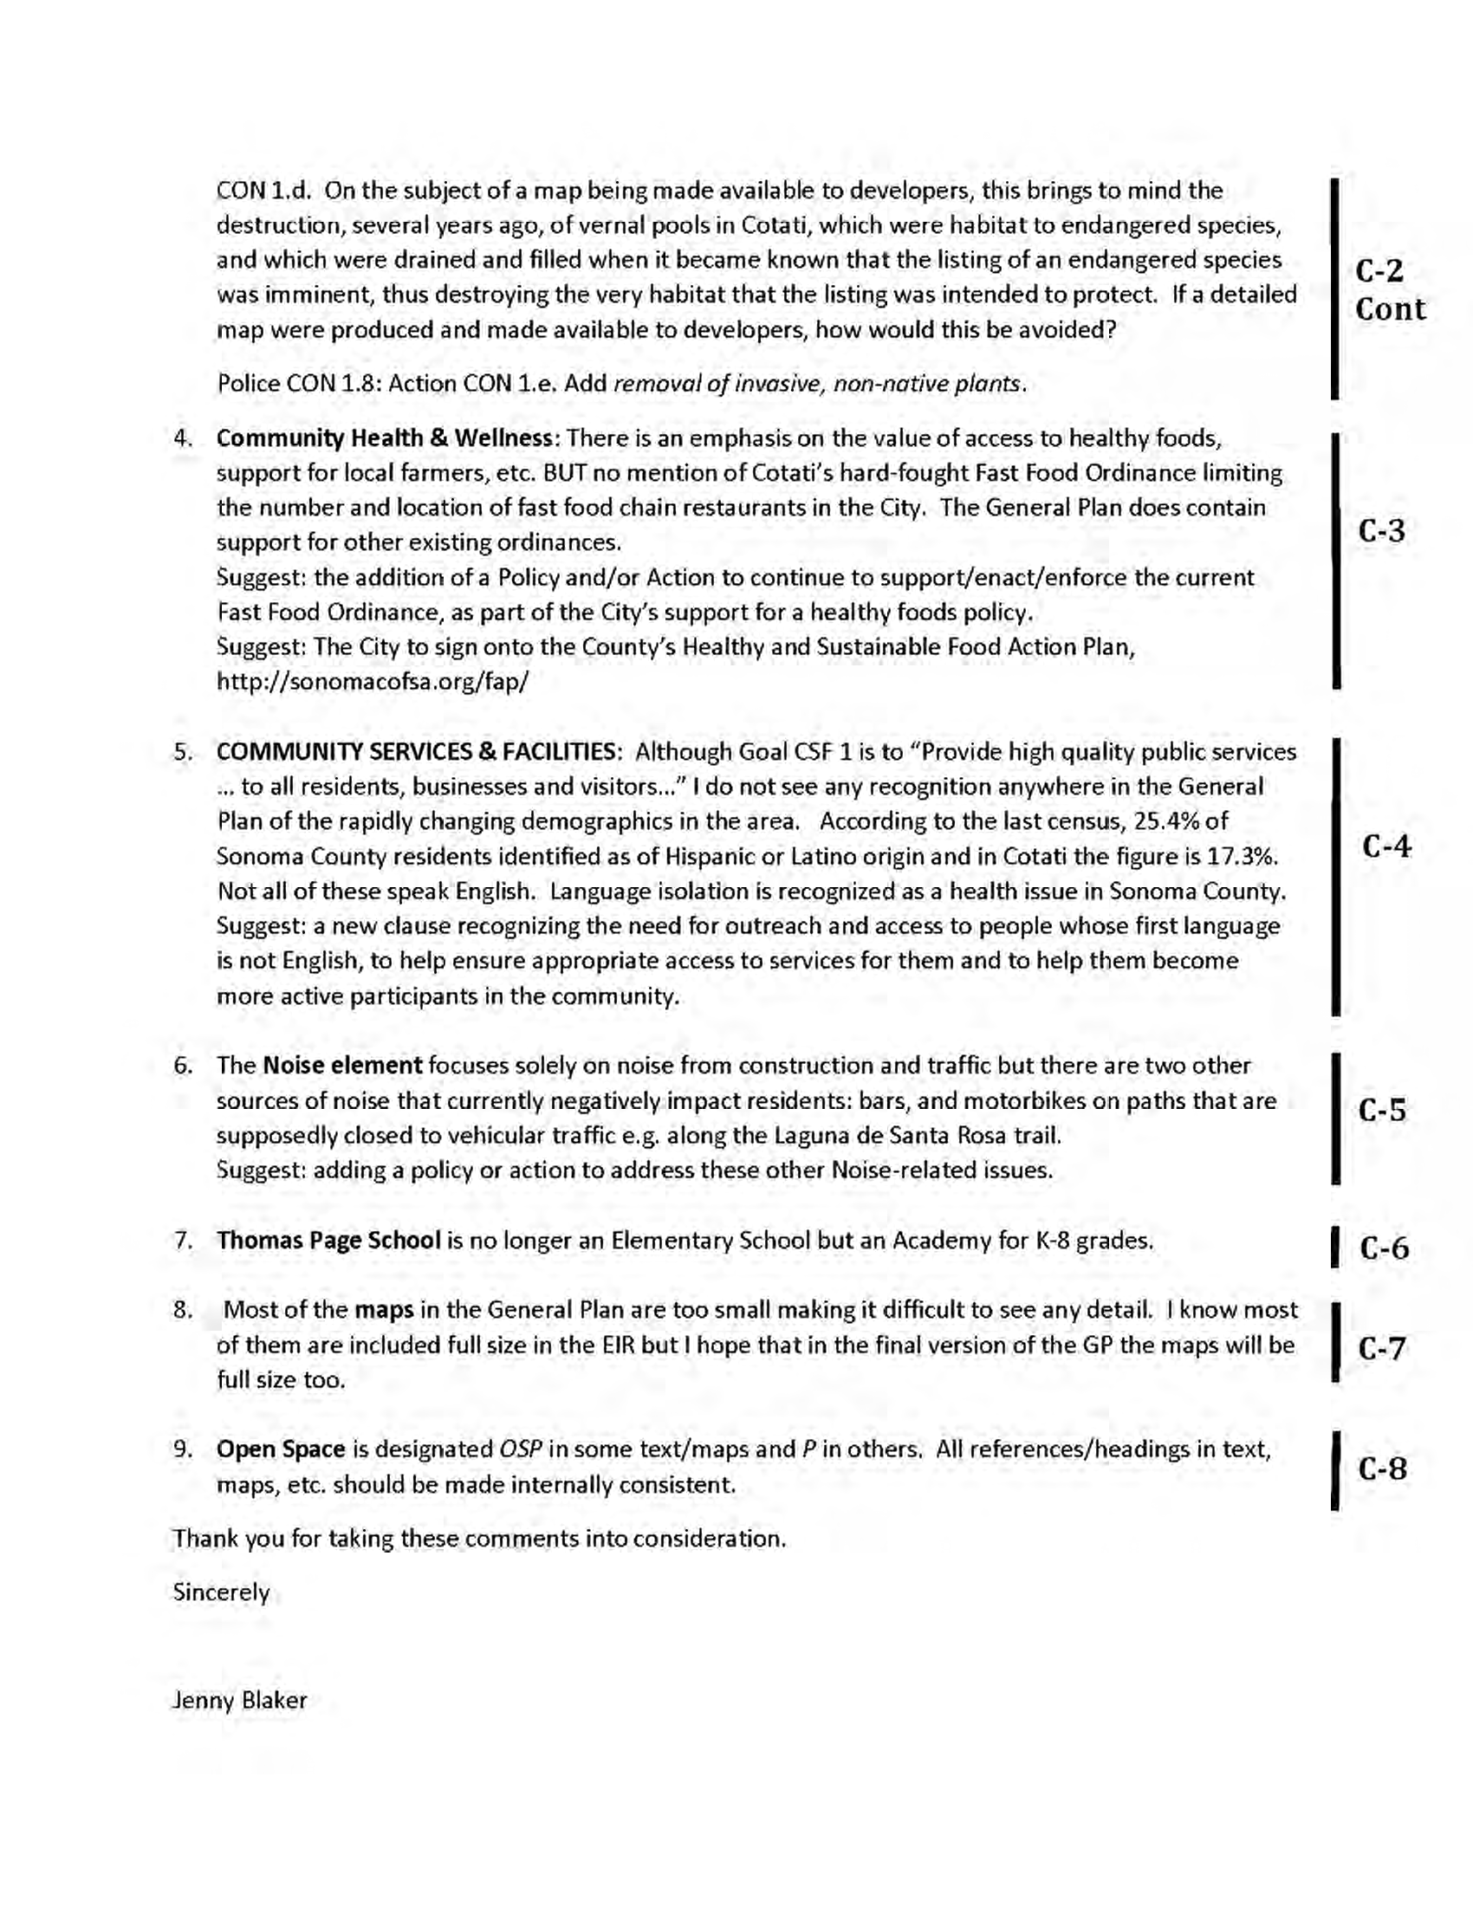
Response to Letter C Jenny Blaker
Response C-1: The commenter notes that the California tiger salamander (CTS) population in Sonoma County is actually listed as Federally Endangered, not Threatened. The commenter also indicates that she believes that this is significant because of the different level of protection afforded to species listed as endangered as opposed to threatened.
The commenter is correct; the Sonoma County population of CTS is federal Endangered. This comment warrants revisions on Page 3.3-10 as follows:

Table 3.3-3: Special Status Animals Present or Potentially Present in Cotati
Species | Status | Habitat

Amphibians
Ambystoma californiense California tiger salamander | FE (Sonoma County DPS)/CT  FT/CT | Need underground refuges, especially ground squirrel burrows and vernal pools or other seasonal water sources for breeding.

The error originated because the CNDDB database (May 2011 and November 2014 queries) provide a “Federal Status” of Threatened when a query is run for special status species in Sonoma County. The CNDDB notes under “General Habitat” indicate that the Sonoma County Distinct Population Segment (DPS) is federally listed as endangered, even though this is not noted under “Federal Status.” Regardless, the correct federal status is “Endangered” for all CTS in Sonoma County’s DPS, including those in and around the City of Cotati. The California status is “Threatened.”
The commenter is correct that an Endangered listing receives a different level of protection under the federal Endangered Species Act; however, it should be noted that under CEQA they are treated equally as special status species. All of the protections of the federal Endangered Species Act are provided to Endangered species. Many, but not all, of the protections of the federal Endangered Species Act are available to Threatened species. Under CEQA, however, both Endangered and Threatened listings warrant a species to fall under the category of “Special Status Species,” which is defined on page 3.3-1 and 3.3-2 of the Draft EIR. More specifically, the term “Special Status Species” encompasses those species that are “Federally listed or proposed for listing under the Federal Endangered Species Act (50 CFR 17.11-17.12).” This broad definition provides an equal treatment for federally Endangered, Threatened, and even those species that are a Candidate for listing when they are not currently listed. As such, the City of Cotati has developed policies that broadly discuss “Special Status Species” regardless of whether their protective status is federally “Endangered” or “Threatened.”
The commenter has also noted that in the last couple of years information about a newly discovered CTS breeding site was submitted by local experts to the California Department of Fish and Wildlife and listed in the CNDDB. The commenter noted that the most recent updates to the CNDDB added this information and that the information should be taken into account.
This comment warranted a new CNDDB database query (November 2014). The new CNDDB query shows an additional CTS occurrence record located at the corner of McGinnis Circle and Ross Street. The occurrence record indicates that the occurrence is from a constructed mitigation vernal pool on an approximately two-acre neighborhood lot. There are roads on two sides and foot paths through the lot. The site is a narrow habitat corridor that links to the upper Laguna Channel. The upland habitat is dense non-native grasses. The pool habitat had emergent vegetation and is up to ten inches deep.
The updated CNDDB query does not warrant text changes to the Draft EIR; however, Figure 3.3-2 and 3.3-3 on Pages 3.3-47 and 3.3-49 were updated to reflect a November 2014 query. These revised figures are included in Chapter 3.0 of this Final EIR.
Response C-2: The commenter provides a range of suggested language related to conservation policies in the Draft General Plan. The City appreciates this input, and these comments and suggestions have been forwarded to the City Council for their review and consideration. Given that these comments do not address the adequacy of the Draft EIR and would have no bearing on the environmental analysis, no changes to the EIR are warranted.
Response C-3: The commenter provides a range of suggested language related to community health and wellness policies in the Draft General Plan. The City appreciates this input, and these comments and suggestions have been forwarded to the City Council for their review and consideration. Given that these comments do not address the adequacy of the Draft EIR and would have no bearing on the environmental analysis, no changes to the EIR are warranted.
Response C-4: The commenter provides a range of suggested language related to community services and facilities policies in the Draft General Plan. The City appreciates this input, and these comments and suggestions have been forwarded to the City Council for their review and consideration. Given that these comments do not address the adequacy of the Draft EIR and would have no bearing on the environmental analysis, no changes to the EIR are warranted.
Response C-5: The commenter provides a range of suggested language related to noise policies in the Draft General Plan. The City appreciates this input, and these comments and suggestions have been forwarded to the City Council for their review and consideration. Given that these comments do not address the adequacy of the Draft EIR and would have no bearing on the environmental analysis, no changes to the EIR are warranted.
Response C-6: The commenter states that Thomas Page School is no longer an elementary school, but an academy for grades K-8. The commenter is correct. Revisions to the General Plan have been made in order to reflect the minor name change of this school and the inclusion of grades 7 and 8 to this school. This minor correction has no bearing on the analysis or conclusions contained in the Draft EIR.
Response C-7: The commenter states that many of the maps in the General Plan are too small, but notes that they are provided in full size in the EIR. The commenter is also directed to the General Plan Existing Conditions Report, which serves as a companion document to the General Plan Policy Document. The small figures contained in the Policy Document are provided as full sized figures in both the Draft EIR and the Existing Conditions Report.
Response C-8: The commenter notes discrepancies in labeling for Open Space and Parks. The General Plan has been updated to resolve these discrepancies.
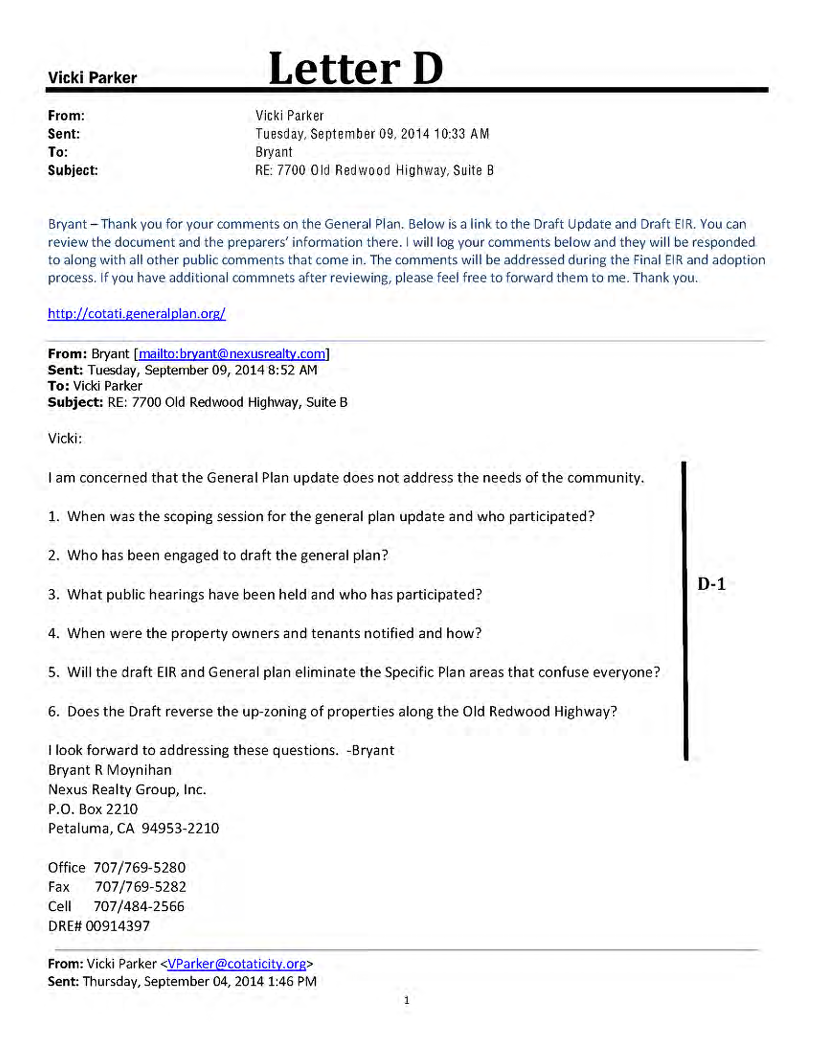
Response to Letter D Bryant R. Moynihan, Nexus Realty Group

Response D-1: The commenter provides a list of questions related to public outreach and engagement during the General Plan Update, and inquires about elimination of Specific Plan areas and zoning of properties along the Old Redwood Highway. The commenter is referred to the General Plan Update website (cotati.generalplan.org) which contains extensive information about past meetings, public hearings, community outreach, and other relevant data regarding the General Plan Update. The General Plan Update process is also summarized on pages 2.0-1 through 2.0-3 of the Draft EIR. With respect to Specific Plan areas and zoning, the commenter is directed to the Land Use Map and the General Plan Land Use Element. As shown in the General Plan, the existing Specific Plans in Cotati have not been eliminated. The General Plan does not change the zoning of any specific parcels within the Planning Area. Changes to General Plan land use designations are shown on the General Plan Land Use Map. No changes to the Draft EIR are warranted.
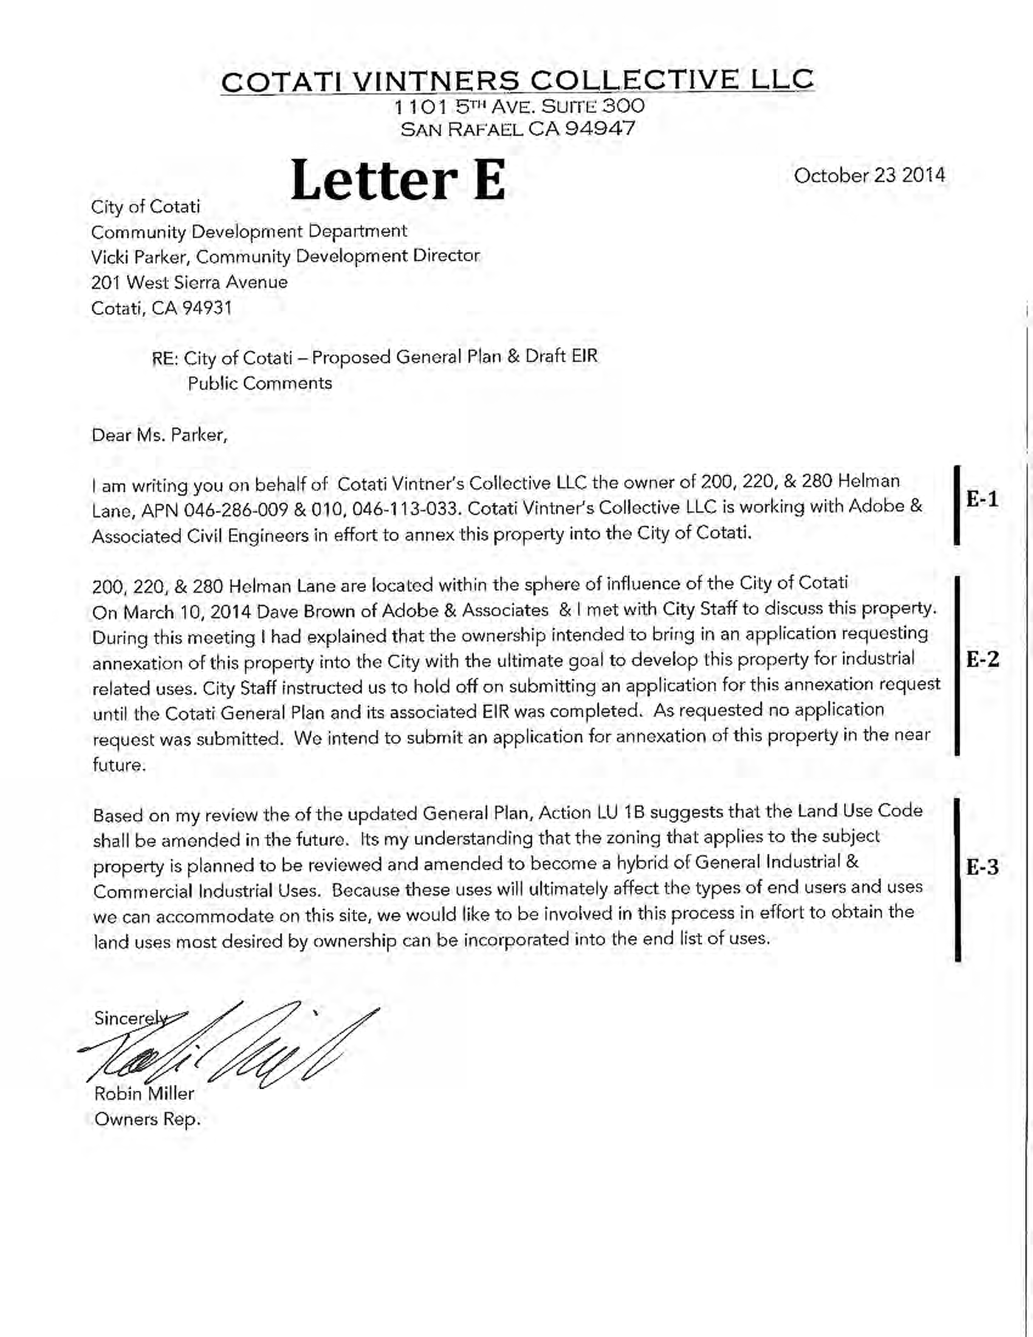

Response to Letter E Robin Miller, Cotati Vintners Collective

Response E-1: The commenter states that the Cotati Vintner’s Collective is working to annex property into the City of Cotati. This comment is noted.
Response E-2: The commenter provides a brief summary of past communications with the City regarding the subject property and indicates an intention to submit an application for annexation in the near future. This comment is noted.
Response E-3: The commenter expresses a desire to be involved in future amendments to the Land Use Code that may affect uses on the subject property. This comment is noted. No changes to the Draft EIR are warranted.
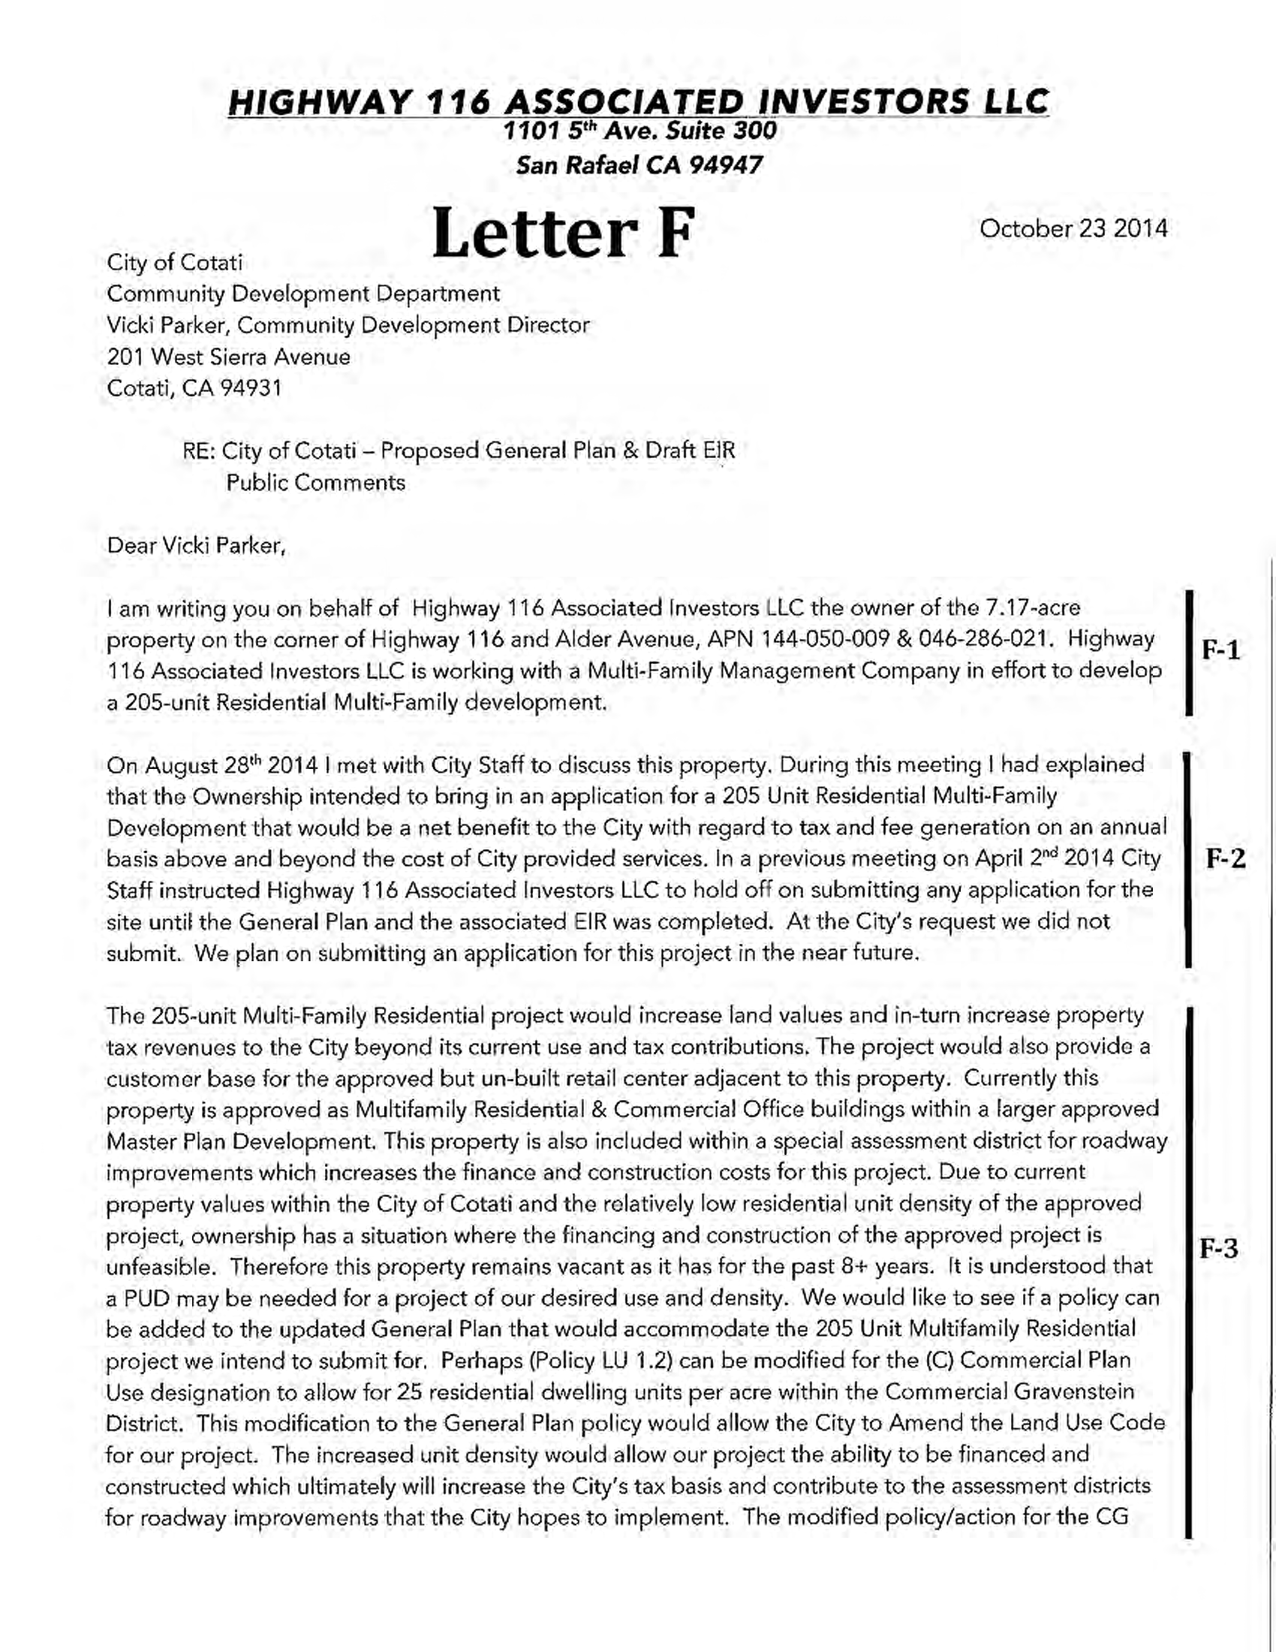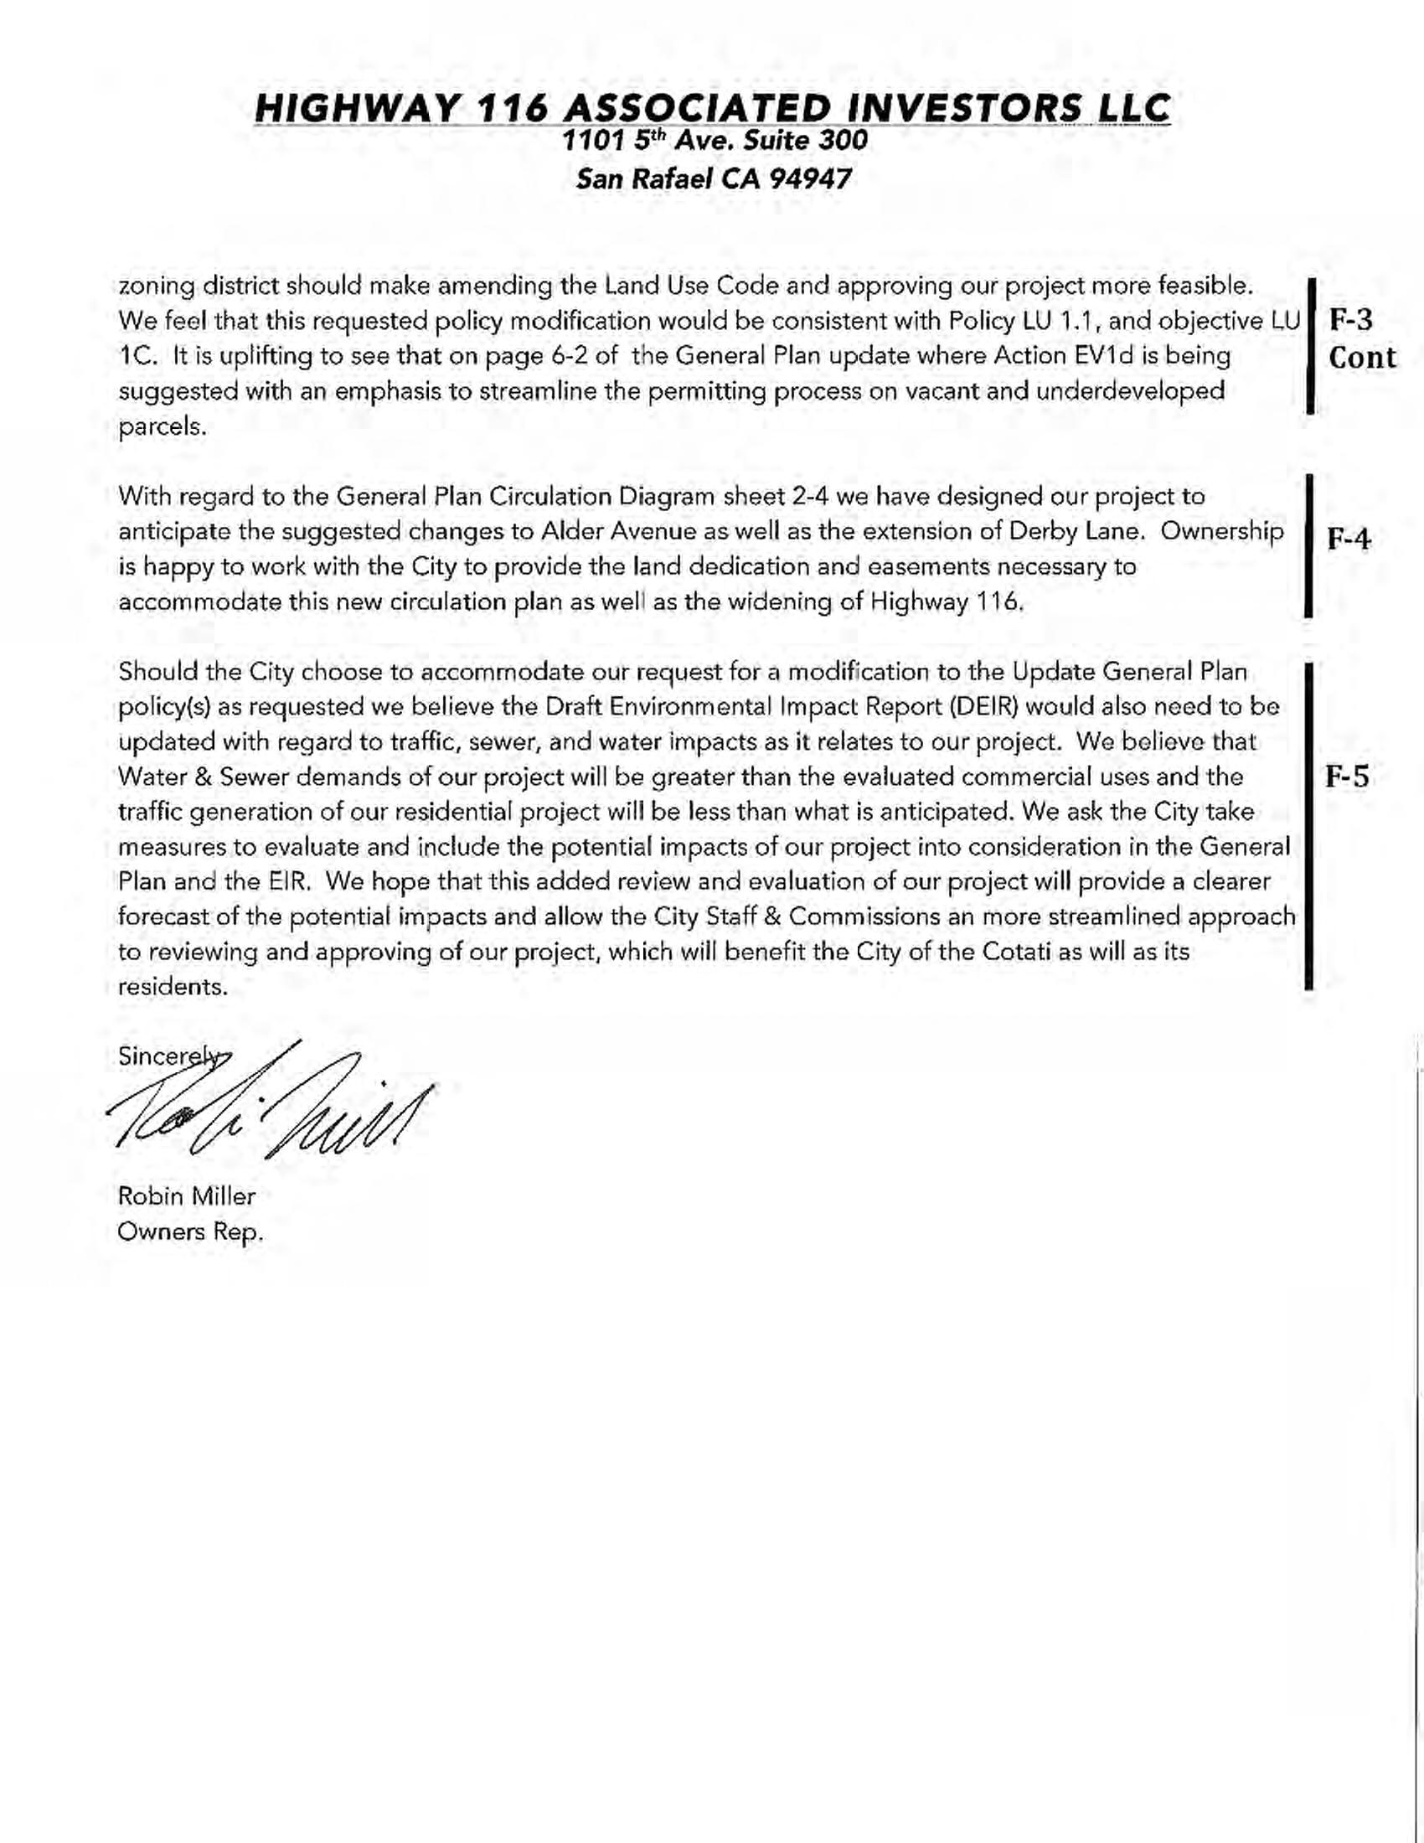

Response to Letter F Robin Miller, Highway 116 Associated Investors

Response F-1: The commenter states that Highway 116 Associated Investors, LLC is working to develop a 205-unit residential multifamily development near the corner of Highway 116 and Alder Avenue. This comment is noted.
Response F-2: The commenter provides a brief summary of past communications with the City regarding the subject property and indicates an intention to submit an application for development in the near future. This comment is noted.
Response F-3: The commenter provides suggested changes to the General Plan to help accommodate the project contemplated by the commenter. This input has been forwarded to the City Council for their consideration. The commenter has not addressed the adequacy of the Draft EIR, and no changes to the EIR are warranted.
Response F-4: The commenter expresses a willingness to work with the City to accommodate planned circulation improvements in the vicinity of the subject property. This comment is noted, and no changes to the Draft EIR are warranted.
Response F-5: The commenter states that if the City chooses to accommodate the commenter’s request for modifications to the General Plan to accommodate the subject project, the Draft EIR would need to be revised accordingly. This comment is noted. If and/or when the commenter or other party submits a formal application for development or re-designation of the subject property, the City will conduct a review of the application consistent with the requirements of CEQA and City planning procedures. At this time, the City is proceeding with approval of the General Plan as written, and as such, no changes to the Draft EIR are warranted. The potential environmental effects of a future application would be addressed under CEQA at the project-level, if and when an application is received and processed by the City.
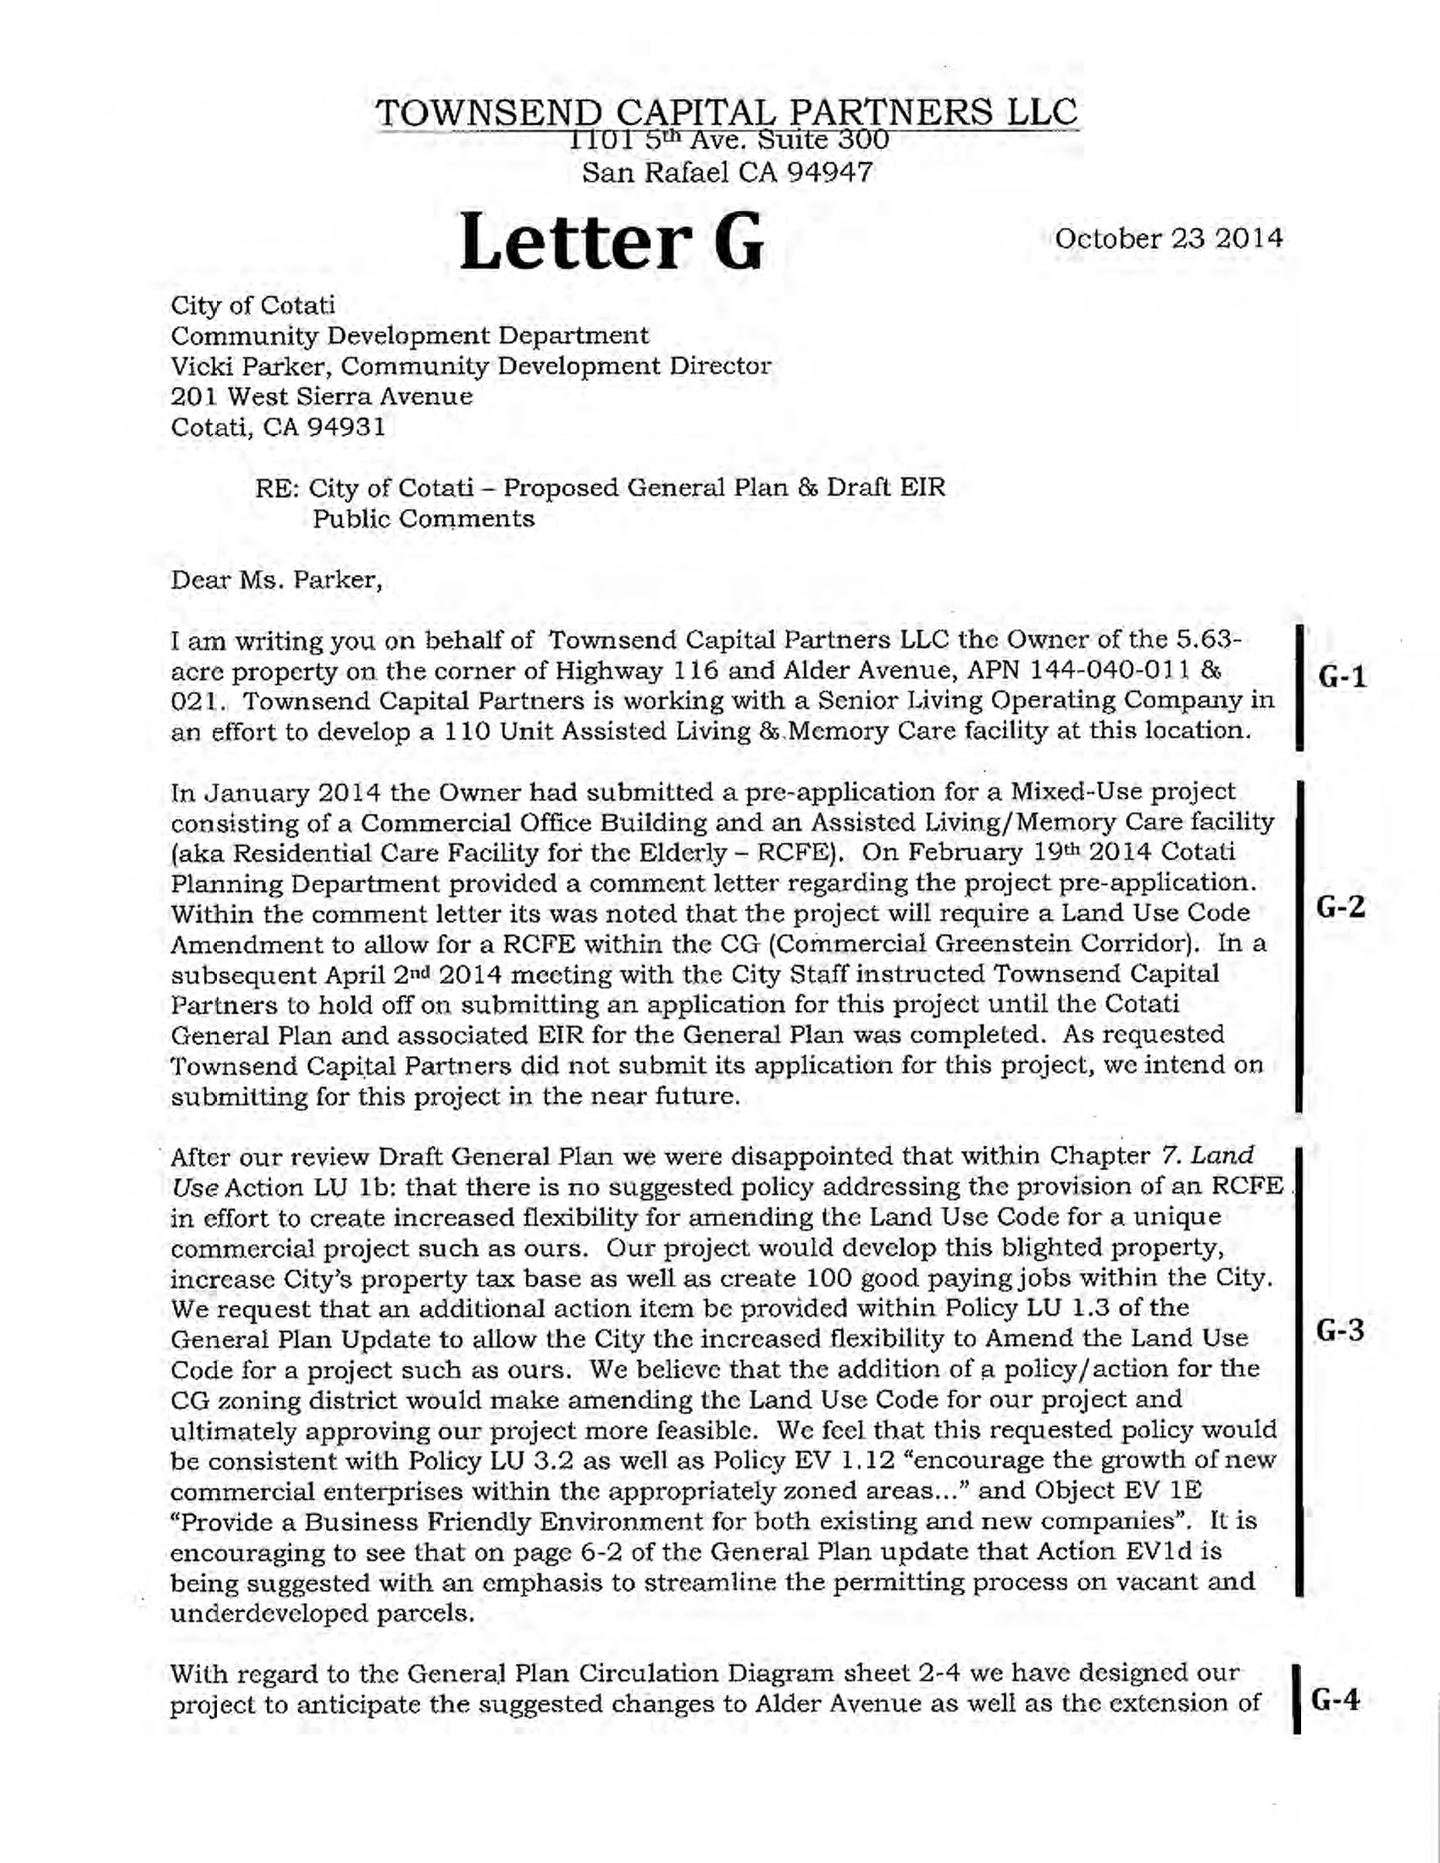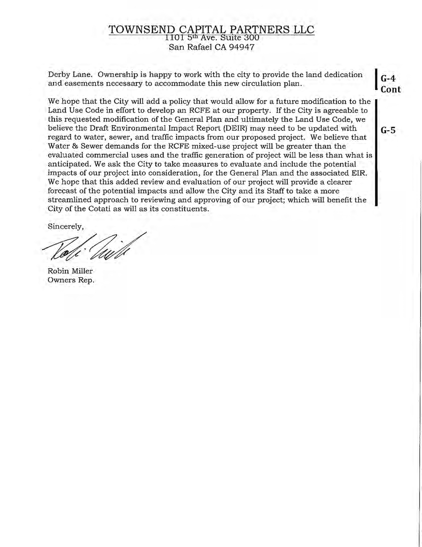

Response to Letter G Robin Miller, Townsend Capital Partners

Response G-1: The commenter states that Townsend Capital Partners, LLC is working to develop a 110-unit assisted living and memory care facility near the corner of Highway 116 and Alder Avenue. This comment is noted.
Response G-2: The commenter provides a brief summary of past communications with the City regarding the subject property and indicates an intention to submit an application for development in the near future. This comment is noted.
Response G-3: The commenter provides suggested changes to the General Plan to help accommodate the project contemplated by the commenter. This input has been forwarded to the City Council for their consideration. The commenter has not addressed the adequacy of the Draft EIR, and no changes to the EIR are warranted.
Response G-4: The commenter expresses a willingness to work with the City to accommodate planned circulation improvements in the vicinity of the subject property. This comment is noted, and no changes to the Draft EIR are warranted.
Response G-5: The commenter states that if the City chooses to accommodate the commenter’s request for modifications to the General Plan to accommodate the subject project, the Draft EIR would need to be revised accordingly. This comment is noted. If and/or when the commenter or other party submits a formal application for development or re-designation of the subject property, the City will conduct a review of the application consistent with the requirements of CEQA and City planning procedures. At this time, the City is proceeding with approval of the General Plan as written, and as such, no changes to the Draft EIR are warranted. The potential environmental effects of a future application would be addressed under CEQA at the project-level, if and when an application is received and processed by the City.

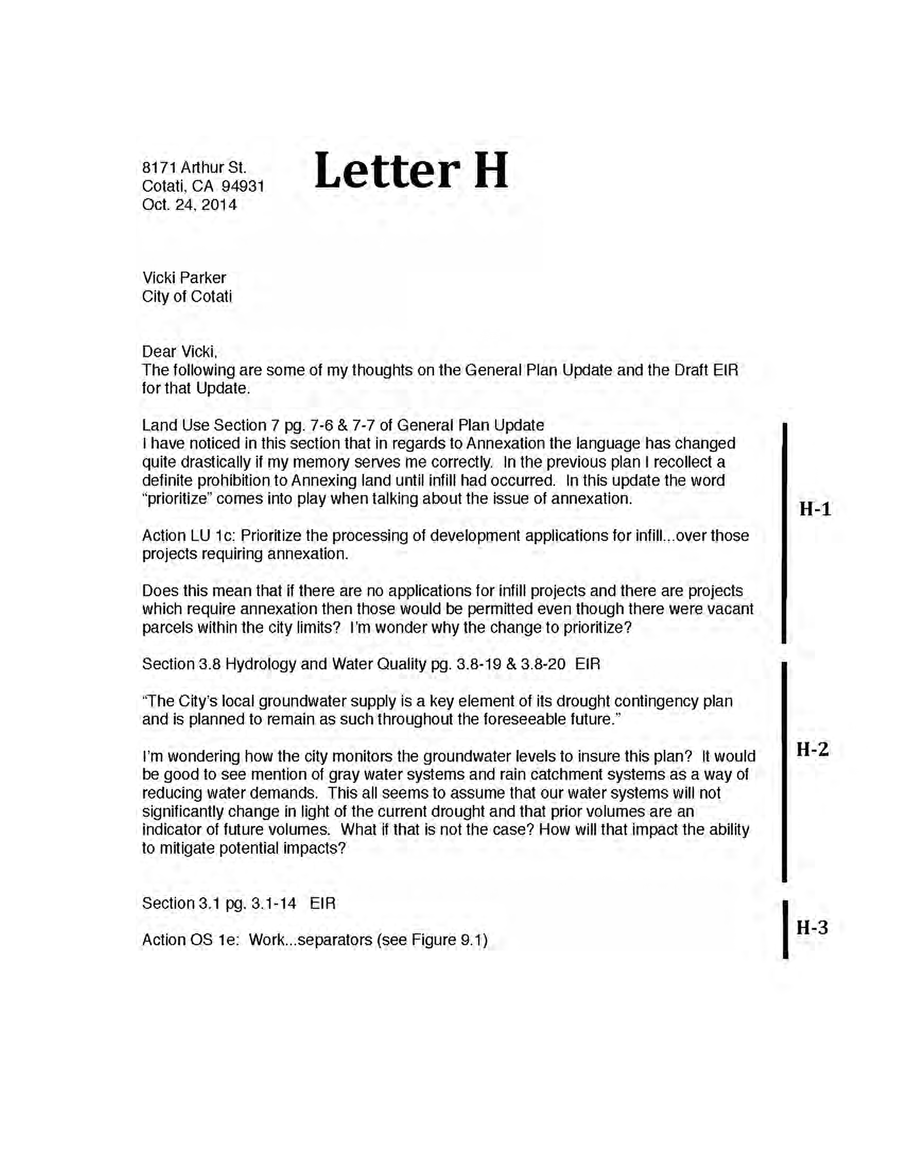
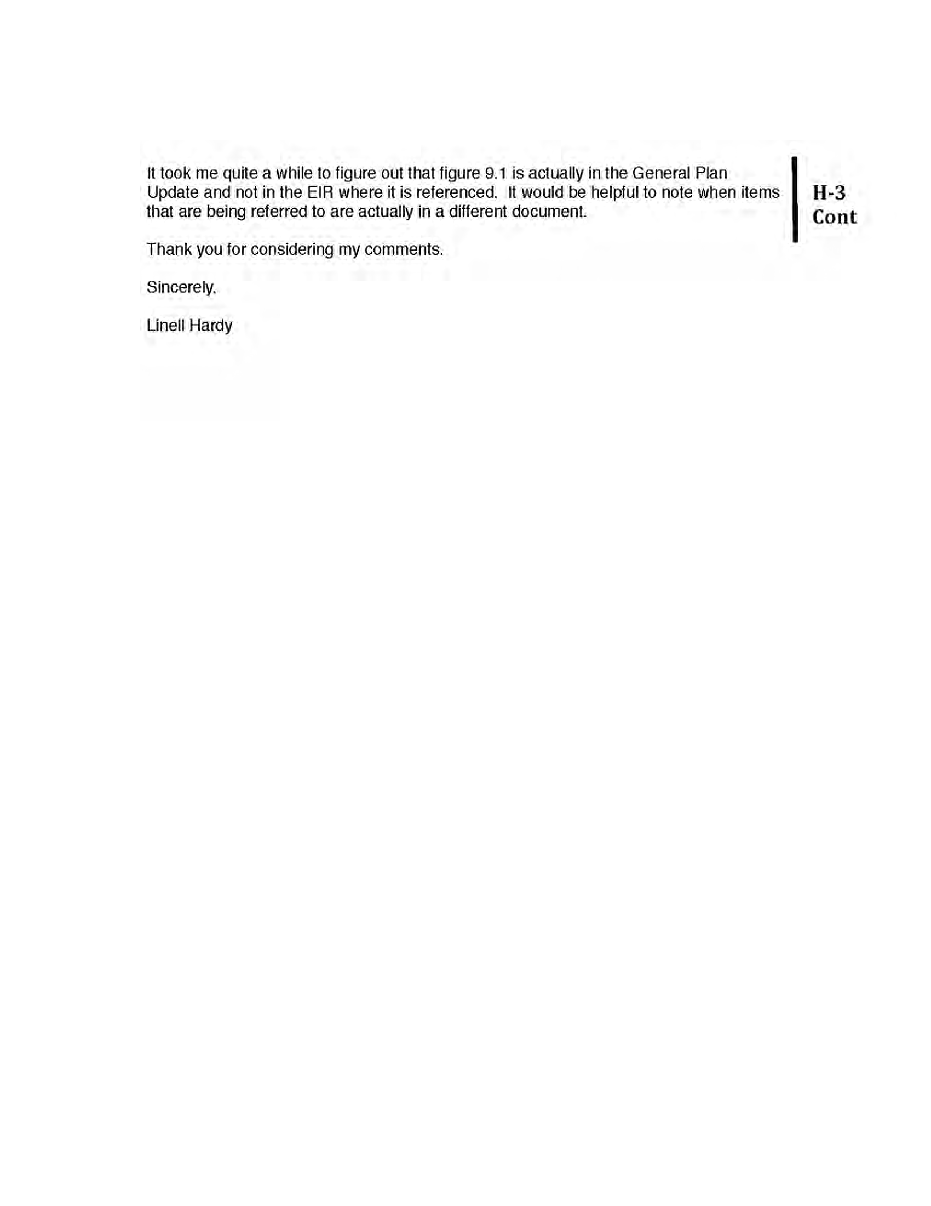

Response to Letter H Linell Hardy

Response H-1: The commenter provides a range of suggested language related to land use policies in the Draft General Plan. The City appreciates this input, and these comments and suggestions have been forwarded to the City Council for their review and consideration. Given that these comments do not address the adequacy of the Draft EIR and would have no bearing on the environmental analysis, no changes to the EIR are warranted.
Response H-2: The commenter questions how drought conditions may impact future water supplies and inquires about the use recycled water systems to reduce demand. The commenter is referred to pages 3.13-1 through 3.13-5 of the Draft EIR, which include a detailed description of existing and future groundwater supplies and surface water supplies. The discussion includes a description of recycled water supplies, and is based on information contained in the 2010 Cotati Urban Water Management Plan (UWMP). In compliance with State law, the UWMP includes an analysis of future water supplies following single, and multiple dry years (drought conditions). The analysis under Impact 3.13-1 in the Draft EIR demonstrates that adequate water supplies existing to meet demand associated with General Plan buildout. The policies and actions included in the General Plan related to water supplies outline and detail the City’s comprehensive approach to ensure that adequate water supplies are available to meet existing and projected demand. The City appreciates the comments provided, and no changes to the Draft EIR are warranted.
Response H-3: The commenter notes that some of the General Plan policies and actions listed in the Draft EIR include references to figures that are not contained in the Draft EIR. This comment is noted. The Draft EIR includes numerous policies and actions from the General Plan that are included in the EIR verbatim. Some of these policies and actions reference figures contained in the General Plan. This comment is noted, and no changes to the Draft EIR are warranted.

This page left intentionally blank.

